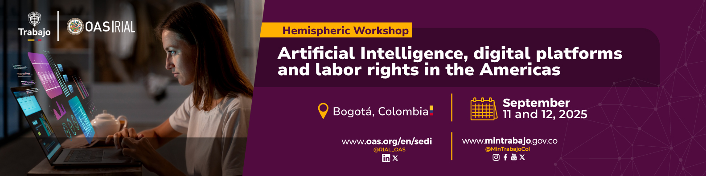
Information Bulletin

Hemispheric Workshop
“Artificial Intelligence, digital platforms and labor rights in the Americas”

Dates: September 11 and 12, 2025
Venue: Bogotá, Colombia
Address: Hotel Tequendama Suites - Carrera 10 #27-51 Interior 150, Bogotá

- Description
The Workshop “Artificial intelligence, digital platforms and labor rights in the Americas” will be held on September 11 and 12 in Bogotá, Colombia, with the aim of enhancing the knowledge and strengthening the capacities of Ministries of Labor and social actors to strategically address the challenges and opportunities presented by technological advancements—particularly AI—in the world of work, while promoting institutional innovation, decent work, and regulatory frameworks aligned with new forms of employment.

This is an activity of the Inter-American Network for Labor Administration (RIAL), co-organized by the OAS and the Ministry of Labor of Colombia, and it is part of the 2025-2027 Work Plan of the Inter-American Conference of Ministers of Labor (IACML).

The Base Document, which accompanies this Bulletin, contains the conceptual framework, objectives, preliminary agenda, and guiding questions for the Workshop.

Participants: Officials from the OAS Ministries of Labor responsible for or involved with the topics addressed in the Workshop; representatives of workers and employers, grouped in the consultative bodies of the IACML - COSATE and CEATAL-; and representatives of international organizations and other interested stakeholders.

- Logistics and travel information
Registration: Participants must complete the Registration Form enclosed in this bulletin and submit it to the IACML Technical Secretariat at trabajo@oas.org by August 20. Those requesting financial assistance must submit the Form by August 5. Government delegates must send the registration forms through the Permanent Mission of their respective countries to the OAS.

Financing: Travel expenses shall be covered by the participating institutions. The OAS, with resources from the RIAL, will be able to fund accommodation for some representatives of Ministries of Labor that require it, and whose responsibilities are aligned with the objectives of the Workshop, as well as for representatives of COSATE and CEATAL.

Resources are limited, thereby applications will be reviewed and awarded on a first-come, first-served basis. Those participants who wish to request financial assistance (accommodation costs) must indicate this in the Registration Form and send it as soon as possible, no later than August 5.

Lodging: Each participant is responsible for booking a room in the hotel of his or her preference, except for those who will be granted financial assistance, in which case, the OAS will make reservations at the designated hotel and cover accommodation costs at the venue.

For participants not receiving financial assistance, the following lodging options are recommended.

Suggested hotels:

Tequendama Suites Bogotá (Event Venue)
Cra. 10 #27-51 Interior 150
Average nightly rate with breakfast: USD $70 USD/night + taxes
Contact: Ruth Suárez, ruth.suarez@tequendamasuites.com
Please mention you are participating in an OAS event

Hyatt Place Bogotá – Convention Center
Ac. 24 #40 – 47
Located approximately 10 minutes by car from the event venue
Average nightly rate with breakfast: USD $73/night + taxes
Contact: Jonathan Ortiz, jhonatan.ortiz@hyatt.com
Please mention you are participating in an OAS event

NH Collection Bogotá WTC Royal
Carrera 8a #99-55, Bogotá, Colombia
Located approximately 25 minutes by car from the event venue
Average nightly rate without breakfast: USD $59/night + taxes
Average nightly rate with breakfast: USD $72/night + taxes
Contact: Cristian Cuevas, nhcollectionroyalwtcbogota@nh-hotels.com
Please mention you are participating in an OAS event

Hilton Bogotá Corferias
Carrera 37 #24-29, Corferias, Bogotá, Colombia
Located approximately 10 minutes by car from the event venue
Average nightly rate with breakfast: USD $220/night + taxes
Average nightly rate with breakfast: USD $238/night + taxes
Contact: Alejandro Murillo, corferias.reservations@hilton.com
Please mention you are participating in an OAS event

Transportation to and from the airport: Each delegate is responsible for making his/her transportation arrangements, except those who will receive financial assistance. The best means of transportation in Bogotá are Uber, DiDi, Cabify, InDriver, or taxi.

Arrival and departure requirements: According to Colombian regulations, all foreign passengers must comply with the immigration procedures established by the Ministry of Foreign Affairs. It is suggested that participants that require a visa head with due diligence to the corresponding diplomatic representation to request it.

More information: https://www.cancilleria.gov.co/tramites_servicios/visa/requisitos

Health considerations:

- There are no entry restrictions for international travelers; however, yellow fever vaccination is recommended when entering high-risk municipalities.

For more information, please check the following link: Public Health | Government of Colombia

- Although it is not mandatory to enter Colombia, it is suggested that participants acquire medical insurance for the duration of their visit.

Language: The meeting will have simultaneous interpretation into English and Spanish.

Weather: In mid-September, the weather in Bogotá is temperate mountain weather, with highs of 19°C (66°F) and lows of 10°C (50°F).

For more information on this meeting, please contact:

ORGANIZATION OF AMERICAN STATES

Maria Claudia Camacho
Chief, Labor and Employment Section, Dept. Human Development, Education and Employment, SEDI
mcamacho@oas.org, Tel: 1 (202) 370-4952

Mariana Vieyra
Program Officer, Inter-American Network for Labor Administration (RIAL), DHDEE/SEDI
trabajo@oas.org, Tel: +52 442 668 9498

MINISTRY OF LABOR OF COLOMBIA
Diego Garzón
Head of the Office of Cooperation and International Relations
dhernang@mintrabajo.gov.co

Lorena Arboleda
Office of Cooperation and International Relations
larboledar@mintrabajo.gov.co

- Registration Form

RIAL/OAS Hemispheric Workshop

“Artificial Intelligence, digital platforms and labor rights in the Americas”

September 11-12, 2025 – Bogotá, Colombia

Last Name |  | First Name
Title

Organization

Country

Telephone | Fax |  | E-mail

Does your institution require financial assistance in order to participate in the meeting?*

Yes ___ No ___

If your response is positive, please submit this Registration Form as soon as possible, and no later than August 5 to: trabajo@oas.org. If you do not request financial assistance, the deadline is August 20.
Government delegates should send this Form through the Permanent Mission of their country to the OAS.
* The OAS, with resources from the Inter-American Network of Labor Administration (RIAL) may fund accommodation costs of some representatives of Ministries of Labor whose responsibilities are aligned with the objectives of the Workshop, as well as representatives from COSATE and CEATAL. Resources are limited, requests for funding will be analyzed and granted on a first-come, first-served basis.

Follow us on @RIAL_OAS; @MinTrabajoCol

