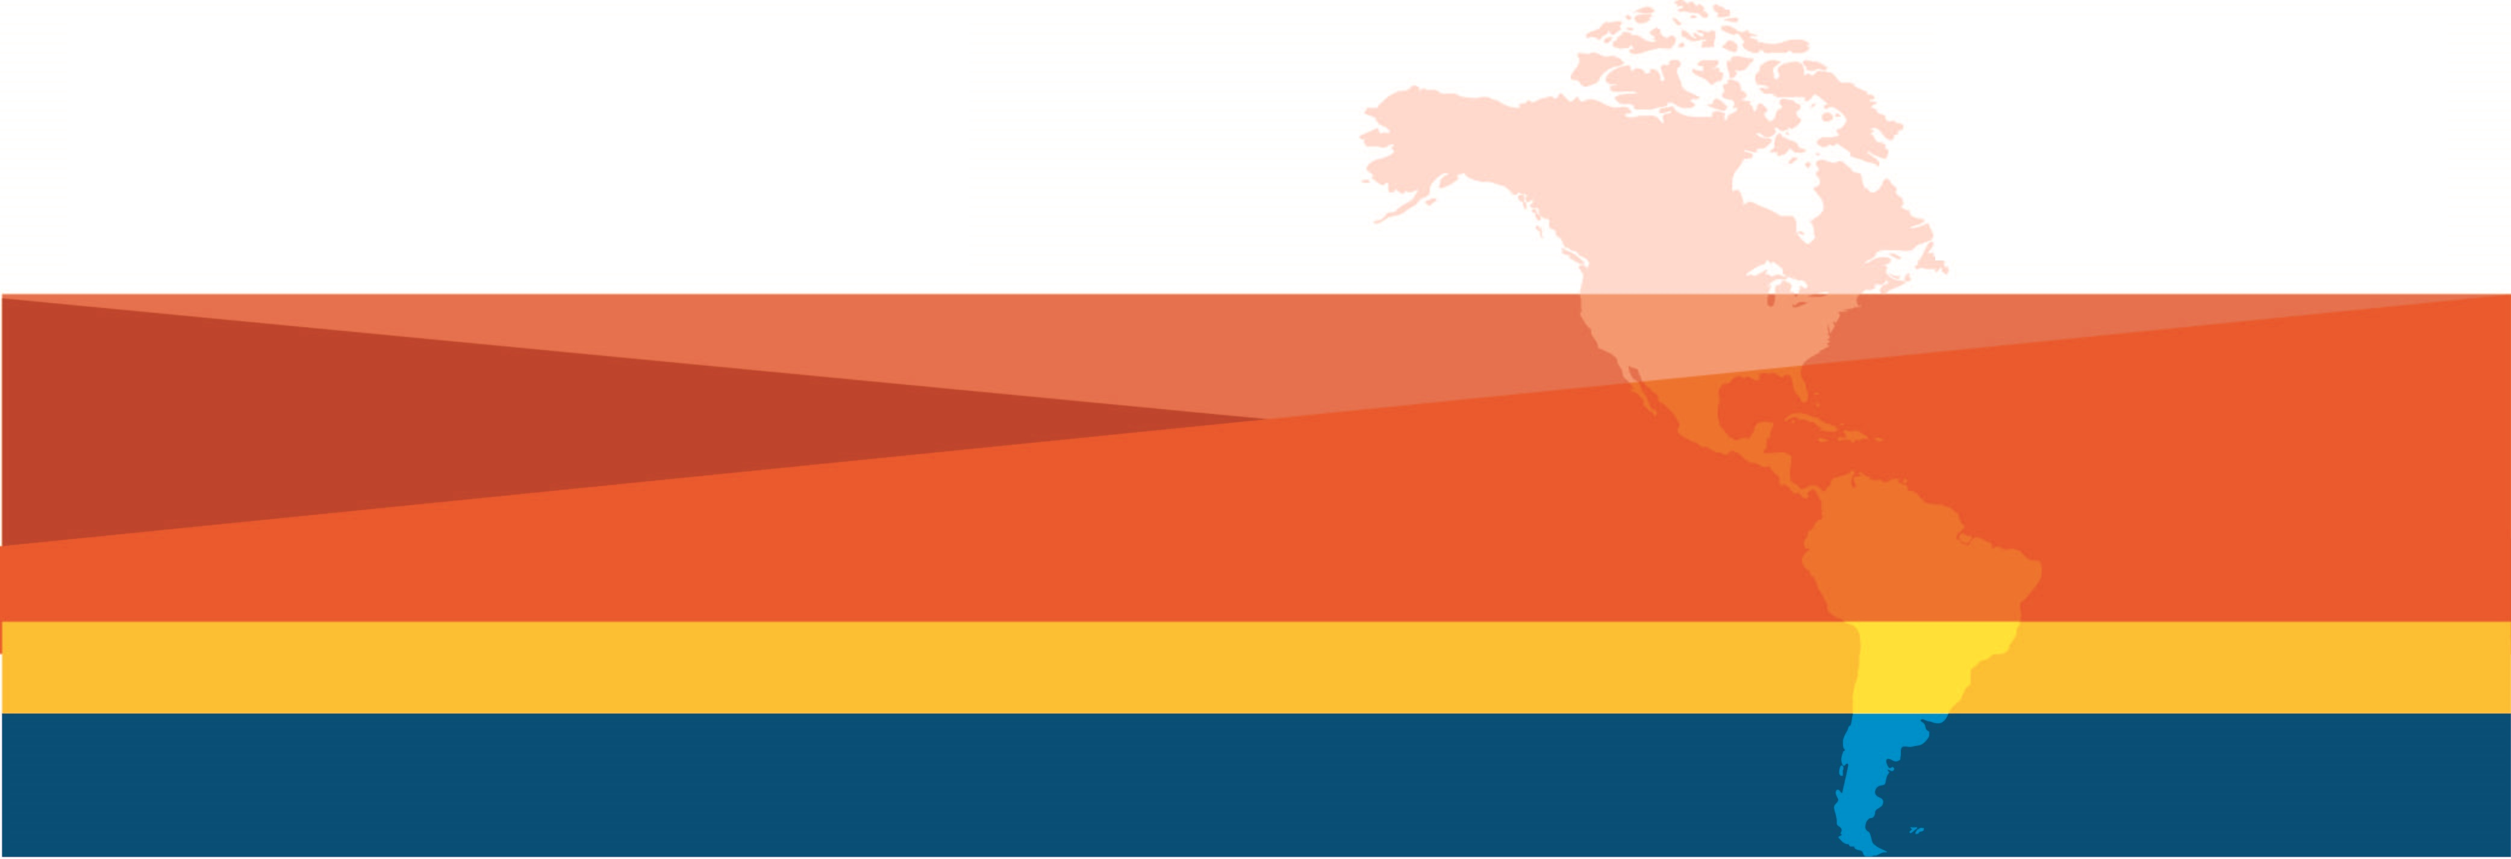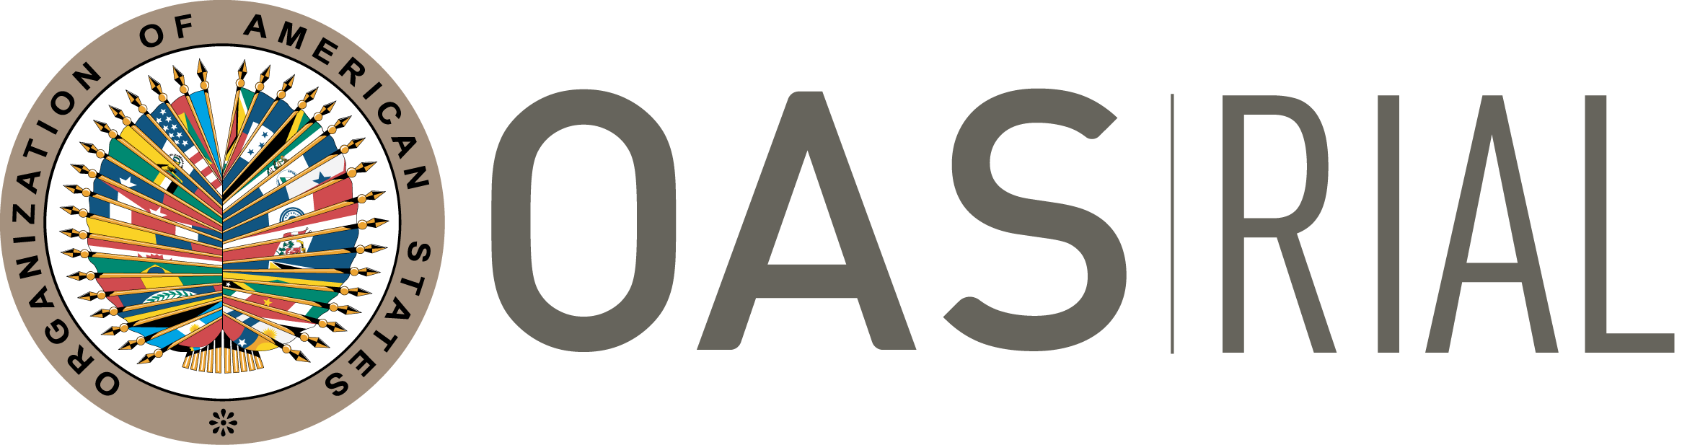
EXTENDED! New deadline March 15
Submission deadline: March 1, 2022
RIAL BILATERAL COOPERATION
15TH Call for virtual activities – 2022

Webinar to answer questions and support proposal development: February 10. Save the date!
Cooperation among Ministries of Labor of the Americas to strengthen their actions, policies and programs.
We invite all Ministries of Labor to submit proposals.

If your Ministry is in the process of creating or improving a program, process, or service, this is your opportunity to obtain technical international cooperation to materialize those outcomes!

15th CALL FOR PROPOSALS - GENERAL GUIDELINES

objective AND Description

The objective of “Bilateral Cooperation” under the RIAL is to support institutional strengthening of the Ministries of Labor through direct technical cooperation among them. RIAL has organized 120 activities of this nature with excellent results that include the development of new services, the improvement of existing programs, and the redesign of training activities, among others. All the results and activities can be found in the webpage: www.rialnet.org.

Since the 1st Call for proposals and up to the 12th Call in 2019, the support provided by RIAL has included technical support and financial resources to cover travel expenses for up to five days for representatives of the Ministries of Labor to receive/provide training in the partner country. Due to the pandemic, during the 13th and 14th Call in 2020 and 2021, the activities took place virtually and resources were allocated to cover the platform, technical support, and simultaneous interpretation, when necessary.

The 15th Call will once again open only for virtual Cooperation Activities, considering the restrictions that may continue throughout the year for travel due to the COVID-19 pandemic.

For the purpose of bilateral cooperation, the parties involved are:

- Providing institution: Ministry of Labor that will share a specific program or expertise, and/or provide training or technical assistance.

- Requesting institution: Ministry of Labor that will analyze a specific program or practice, or that will receive technical cooperation.

- Technical Secretariat (OAS): Coordinates technical and logistical aspects of the cooperation. It provides input to the agenda and content, manages the technological platform, follows up and promotes exchanges between sessions.

The activities are generically called “Cooperation Activities”.

operation and procedures

- Identification of Cooperation Needs The first step that should be taken by a requesting institution is to determine its international cooperation needs, based on its institutional priorities.

Example: A Ministry has among its priorities or strategic plan the restructuring or creation of a new area, the reform of an internal procedure, or the design of a new policy. To achieve this goal (one of them), it considers it timely and pertinent to learn about the experience and obtain technical assistance from another Ministry.

NOTE: For this Call, a fundamental step is for the Requesting Institution to analyze and ensure that the objectives it pursues are achievable through a VIRTUAL cooperation activity.

- Identification of providing institution: In order to identify the Ministry that can better provide the technical support, requesting Ministries have different means:
- Consult RIAL Portfolio of Programs at www.rialnet.org and identify experiences that respond to their cooperation needs and priorities.
- Take advantage of the relationships among RIAL focal points as well as the information and contacts obtained during workshops and meetings of the OAS Inter-American Conference of Ministers of Labor (IACML), ILO or other relevant fora, where delegates have the opportunity to meet, exchange ideas and identify possible channels for further cooperation.
- Consult the Technical Secretariat, at the Department of Human Development, Education and Employment of the Executive Secretariat for Integral Development of the OAS (SEDI/OAS), who can support the identification of possible providing institutions and facilitate the interaction between Ministries that do not already have direct communication channels.
- Participate in the Informative Webinar on February 10, which will include a match-making session.

- Proposal development – Complete “Request form”: The RIAL focal points should negotiate the cooperation proposals and support technical areas of their Ministries in identifying experiences and potential providers, based on their institutional strengthening needs and priorities.

The Technical Secretariat will organize a Webinar on February 10 to assist Ministries in the presentation of proposals and contribute to identifying possible partners. Click here to register.

During the negotiation process, it is suggested that the requesting institution completes the Request Form and shares it with the potential providing institution, so that they can better understand the justification and objectives and decide how to better support the requesting institution. Once an agreement is reached between both institutions, the providing institution will be able to add inputs into the Request Form to improve it.

The providing institution will send the requesting institution the letter mentioned in point “c” of the following section, confirming its commitment to undertake the cooperation activity, in case the proposal is selected.

- Proposal submission: Each Requesting Institution must submit to the SEDI/OAS, through its RIAL focal point and Permanent Mission to the OAS, a request for each cooperation activity it wishes to undertake. This request should contain the following documents:
    - Request Form – Attached at the end of this document.
    - A letter from the requesting institution addressed to the RIAL Technical Secretariat, signed by the Minister or a High-ranking official, sending the Request Form and stating their commitment to develop a final output (work plan, report, project, policy proposal, etc.) as a result of the cooperation activity, in case the proposal is selected.
    - A letter from the providing institution, signed by the Minister or a high-ranking official, addressed to the requesting institution (Ministry of Labor of the country that requested the cooperation), confirming their commitment to undertake the cooperation activity in case the proposal is selected. This letter should also include the commitment of the providing institution to enrich and provide inputs to the final output prepared by the requesting institution.

Completed applications should be received no later than Tuesday, March 10, 2022.

NOTE: For the proposals to enter the selection process, the Technical Secretariat should receive all three documents through the Permanent Mission of the country to the OAS.

- Selection of Cooperation Activities to be funded: The OAS will receive and select the activities to be funded, based on the criteria listed below. Selections are final and not subject to appeal.

The criteria to select the activities are:
  - Pertinence and timeliness of the cooperation - the justification/rationale for the activity shows why cooperation is required at this time
  - Objectives are clear, pertinent, and achievable through virtual cooperation activities
  - Clarity and relevance of the cooperation’s final output
  - Explicit commitment on the part of the parties involved
  - Degree of relevance of the topic for the IACML
  - Priority will be given to proposals arising from activities of the RIAL and the IACML, and to those that are receiving co-financing from the requesting institution

Note on ineligibility: The Ministries that have not submitted final reports from previous activities or follow-up surveys will not be eligible to receive new cooperation resources.
- Undertaking and Funding of Cooperation Activities: Activities of this call for proposals will take place virtually between April and December 2022, and those that are not completed at the end of this period will be canceled.

The Technical Secretariat, after announcing the proposals selected, will contact each of the Ministries involved to set a planning session in order to introduce the teams involved, share expectations and objectives, define a timeline and draft contents for the cooperation sessions.

Typically, the activity will consist of three virtual cooperation sessions, in addition to the planning session, with a space of approximately one month between each of them. Each virtual session will last between two and three hours. Prior to the first session and between each subsequent ones, reports, documents and specific questions to be addressed during the sessions will be exchanged.

The main goal during the various cooperation sessions, is for the Requesting Institution to strengthen its internal practices and produce a final output with the lessons learned and recommendations from the experience of the providing institution.

The cooperation sessions will take place through the “ZOOM” Platform of the Department of Human Development, Education and Employment, with the technical and logistical support of the Technical Secretariat and will be fully recorded. In the case that a selected activity requires simultaneous interpretation, the Technical Secretariat will provide this service.

Benefits of having a virtual bilateral cooperation
- Opportunity for sharing all relevant information (documents, presentations, legal framework, among others) prior to the cooperation and between sessions.
- More space between sessions – which allows for real support from the providing institution in the process that the requesting institution is pursuing, and not only during the five-day on-site mission. Thus, the providing institution will be able to see and analyze advancements from its counterpart.
- Possibility to involve more officers.
- Possibility to have more sessions (3 sessions).

- Final Output: In the last cooperation session, the requesting institution should present a final output (report, work plan, project, policy proposal, etc.), incorporating the main lessons learned and recommendations derived from the experience of the providing institution. It will also present a brief work plan with next steps to continue strengthening the requesting institution’s actions in the area of the cooperation. The providing institution will provide feedback, including specific inputs and recommendations, to the final output and the work plan.

- Follow-up: Six months after the completion of the activity, the OAS will send a follow-up survey to identify the results and impacts of the cooperation. The OAS will prepare a summary report of completed activities, and the achieved results will be presented during the IACML meetings.

A bilingual Webinar will take place on February 10th to address questions and support proposal development. In the meantime, for any questions please contact María Claudia Camacho, RIAL Coordinator at mcamacho@oas.org, or Guillermo Calzada, RIAL Program Officer at gcalzada@oas.org

RIAL BILATERAL COOPERATION
REQUEST FORM – 15 CALL FOR PROPOSALS - 2021
To be sent no later than March 10, 2022 to:

Executive Secretariat for Integral Development (SEDI), OAS
Att. Maria Claudia Camacho, Chief of the Labor & Employment Section, RIAL Coordinator
E-mail: trabajo@oas.org; mcamacho@oas.org

To complete your submission please send the following along with this request form: Letter from the requesting institution and letter from the providing institution with the details indicated in the Guidelines of this Call for proposals (section “2: Request for funding”)

(The area of the cells is expandable. Please use all the space you consider necessary)

Requesting institution (include country): | Providing institution (include country):
Thematic area of cooperation activity requested:
Justification: Briefly specify why this cooperation is needed at this point in time, state the specific challenges your Ministry is facing in the area that is covered by this cooperation activity and the reasons for choosing the providing institution.

General objective and specific objectives of this virtual cooperation: Please list precise, clear and achievable general objective and specific objectives

Proposed final output of this cooperation: Please indicate the concrete output your Ministry expects to attain as a result of this cooperation. Final output may include a project, policy proposal, work plan, report, among others.

Specification of other support: Please indicate if your institution has requested or received financial or technical assistance from international agencies or governments in the area of this cooperation.
Identification of providing institution: Please indicate how the providing institution was identified, for example RIAL Portfolio of Programs, direct contact, publication or Workshop/Seminar.
Co-financing: Will additional funding be provided (other than RIAL)?
___ No
___ Yes. Please specify: ___________________
Contact information (Name, title, e-mail and phone of the individual preparing this request):

RIAL focal points are generally the offices of international affairs or cooperation of the Ministries of Labor. An updated list of focal points is available in the RIAL website: www.rialnet.org .

